CS2102 AY2017/18

Jeffery Kwoh Ji Hui

Vignesh Shankar

Chik Cheng Yao

Mok Ken Han, Evan

ER Diagram

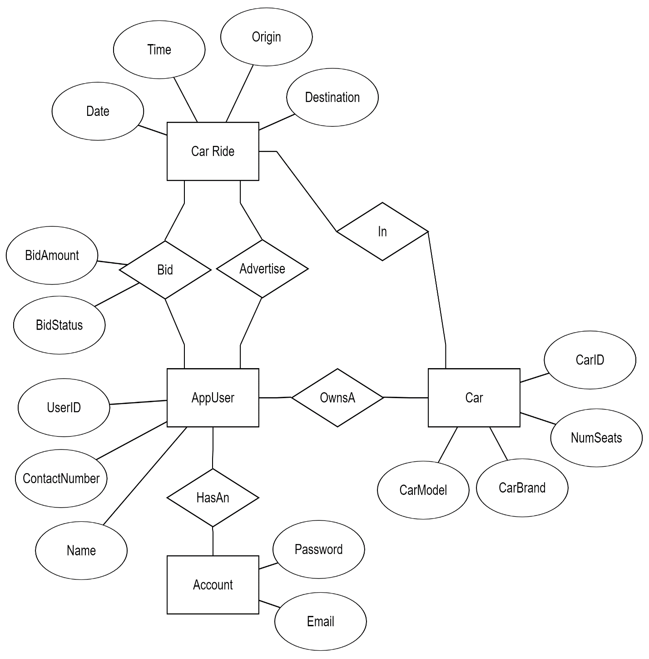

Legend:

: Entity

: Attribute

: Relationship

Relational Schema (SQL DDL code)

CREATE TABLE account (

email VARCHAR(64) PRIMARY KEY,

password_hash VARCHAR(80) NOT NULL

);

CREATE TABLE appUser (

userID SERIAL PRIMARY KEY,

contactNumber VARCHAR(15) UNIQUE,

name VARCHAR(255) NOT NULL

);

// I’m guessing this table can be eliminated? Since it’s a one to one mapping.

// Just need to make User reference the keys in Account

CREATE TABLE hasAn (

userID INTEGER NOT NULL,

email VARCHAR(64) NOT NULL,

PRIMARY KEY(userID, email),

FOREIGN KEY (userID) REFERENCES appUser(userID),

FOREIGN KEY (email) REFERENCES account(email)

);

CREATE TABLE car (

carID SERIAL PRIMARY KEY,

carBrand VARCHAR (64) NOT NULL,

carModel VARCHAR (64) NOT NULL,

numSeats integer NOT NULL

);

CREATE TABLE ownsA (

owner INTEGER REFERENCES appUser(userID),

carID INTEGER REFERENCES car(carID)

PRIMARY KEY(userID, carID)

);

CREATE TABLE carRide (

car INTEGER REFERENCES car(carID),

date DATE NOT NULL,

time TIME NOT NULL,

origin VARCHAR(128),

destination VARCHAR(128),

PRIMARY KEY (date, time, car, origin, destination)

);

CREATE TABLE advertise (

userID INTEGER,

date DATE NOT NULL,

time TIME NOT NULL,

origin VARCHAR(128),

destination VARCHAR(128),

car INTEGER,

FOREIGN KEY(userID) REFERENCES appUser(userID),

FOREIGN KEY(date, time, car, origin, destination)

REFERENCES carRide(date, time, car, origin, destination),

PRIMARY KEY(userID , date, time, origin, destination, car)

);

CREATE TABLE bid (

bidStatus CHAR(12) CONSTRAINT bidStatus CHECK(bidStatus = 'pending' OR

bidStatus ='unsuccessful' OR bidStatus = 'successful') NOT NULL,

bidAmount INTEGER NOT NULL,

userID INTEGER NOT NULL,

date DATE NOT NULL,

time TIME NOT NULL,

origin VARCHAR(128),

destination VARCHAR(128),

car INTEGER,

FOREIGN KEY(userID) REFERENCES appUser(userID),

FOREIGN KEY(date, time, car, origin, destination)

REFERENCES carRide(date, time, car, origin, destination),

PRIMARY KEY(bidStatus, bidAmount, userID , date, time, origin, destination, car)

);